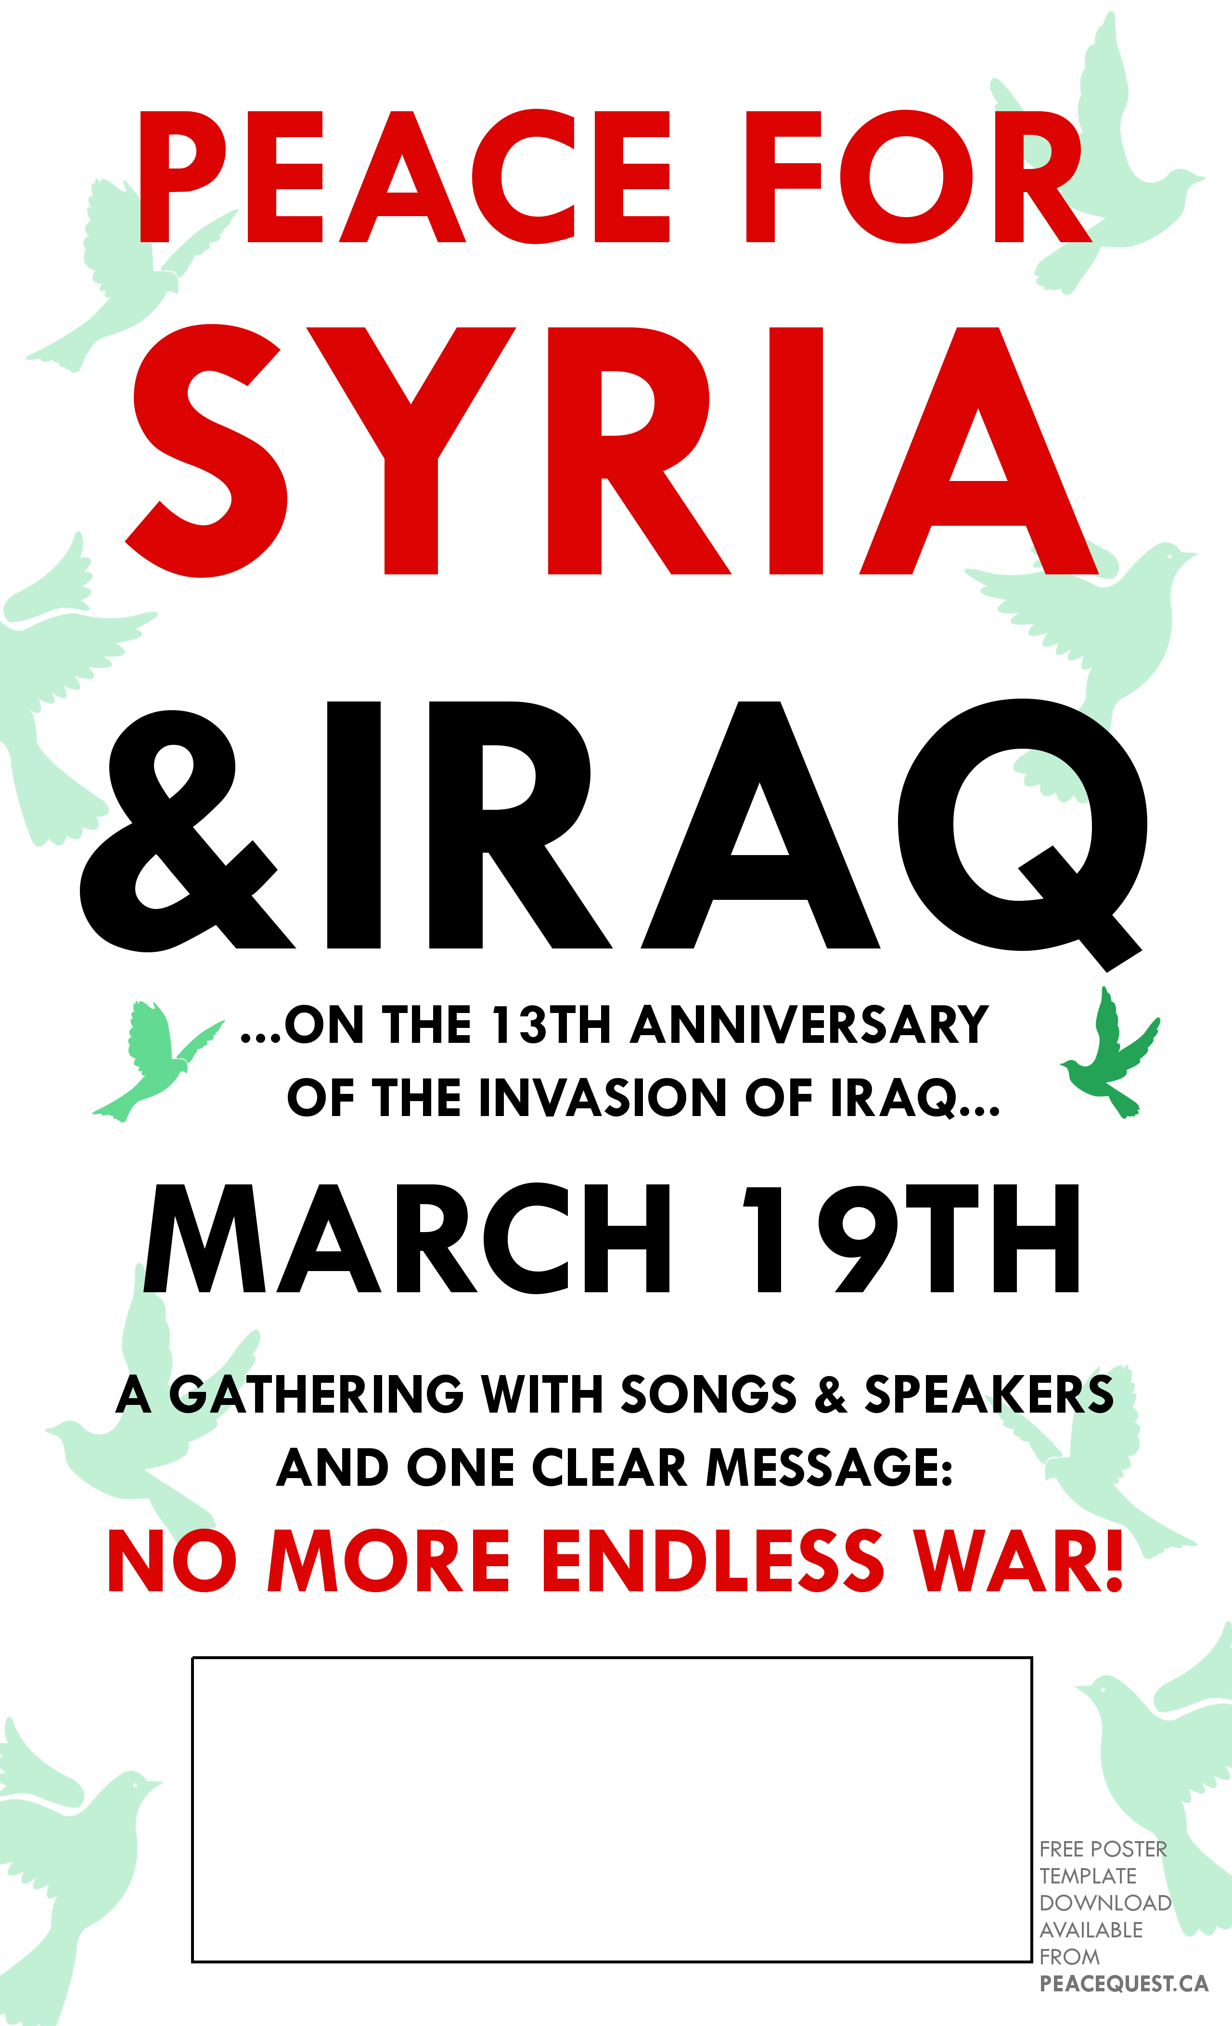

**REGINA CITY HALL – 1PM**

**AT THE PEACE FOUNTAIN**

*Brought to you by:*

**Making Peace Vigil, PeaceQuest Regina**

**& the Regina Peace Council**